ACTION METHOD IN ASP.NET MVC 5?
All the public methods which are written inside a Controller are known as Action Method. When creating Action Method you must follow these rules.
a. Action method must be public.
b. It cannot be overloaded.
c. It cannot be a static method.
d. Every controller has at least one default Action method Index() that returns the view page.
e. ActionResult is a base class of all the result type action methods.
TYPES OF ACTION METHOD
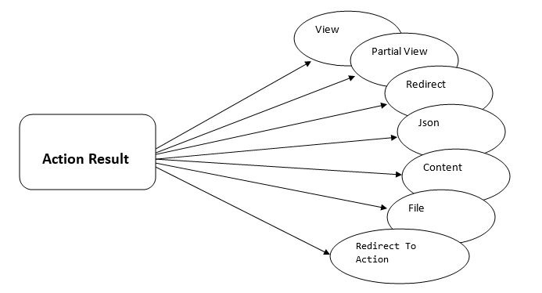
ActionResult is the base class of all the result type action method. There are following Result type action method in MVC.
ViewResult - Represents HTML and markup.
EmptyResult - Represents no result.
RedirectResult - Represents a redirection to a new URL.
JsonResult - Represents a JavaScript Object Notation result that can be used in an AJAX application.
JavaScriptResult - Represents a JavaScript script.
ContentResult - Represents a text result.
FileContentResult - Represents a downloadable file (with the binary content).
FilePathResult - Represents a downloadable file (with a path).

FileStreamResult - Represents a downloadable file (with a file stream).
Programming Example
1. ViewResult
- // GET: Item
- public ViewResult Index()
- {
- ViewBag.ItemList = "Computer Shop Item List Page";
- return View();
- }
Output: It will return Index View Page
EmptyResult
- //GET: Item
- public EmptyResult Index()
- {
- ViewBag.ItemList = "Computer Shop Item List Page";
- return new EmptyResult();
- }
Output: It will return a blank page with no result.
RedirectResult
Redirect Results is used for returning results to specific url. When you need to redirect to another action method, you can use RedirectResult Action Method.
- public RedirectResult Index()
- {
- return Redirect("Home/Contact");
- }

When you will run this code, It will redirect you to Contact Page.
JSONResult
JSON Result returns simple text file format and key value pairs. Sometimes you may want to return data in JSON Format and that situation you JSONResult is the best option.
- public JsonResult Index()
- {
- Employee emp = new Employee()
- {
- ID = "Emp23",
- Name = "Steven Clark",
- Mobile = "825415426"
- };
- return Json(emp, JsonRequestBehavior.AllowGet);
- }
- public class Employee
- {
- public string ID { get; set; }
- public string Name { get; set; }
- public string Mobile { get; set; }
- }
Output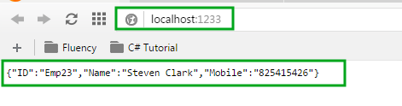
JavaScriptResult
It returns java script that can be executed on the client browser. It sends javascript content in response to browser. This block allow you to execute java script on client at run time.
Example:
Step 1: Add this JavaScriptResult() method in home controller.
- [HttpPost]
- public ActionResult Index(string name)
- {
- ViewBag.Message = String.Format("Hello{0}.\\ncurrent Date and time:{1}", name, DateTime.Now.ToString());
- return View();
- }

Step 2: Open Index.cshtml and add the following highlighted code.
- @using (Html.BeginForm("Index", "Home", FormMethod.Post))
- {
- <input type="text" id="txtName" name="name" />
- <input type="submit" id="btnSubmit" value="Get Current Time" />
- }
- @if (ViewBag.Message != null)
- {
- <script type="text/javascript">

- window.onload = function () {
- alert("@ViewBag.Message");
- };
- </script>

- }
- </body>
- </html>

Output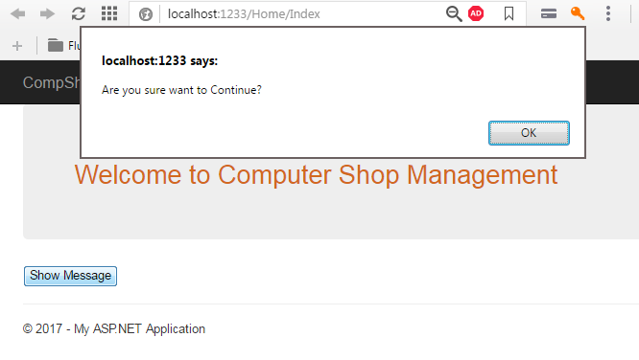
Content Result
It returns user-defined content type. It is useful when you want to send some plain text message to browser screen.
- public ContentResult Index()
- {
- return Content("Hello ASP.NET MVC 5", "text/plain", System.Text.Encoding.UTF8);
- }
Output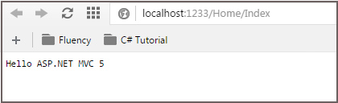
File Result
It represents the content of the file.
Step 1: Add following code in HomeControllers
- [HttpGet]
- public FileResult Download()
- {
- byte[] fileBytes = System.IO.File.ReadAllBytes(@"D:\folder\myfile.txt");
- string filename = "myfile.txt";
- return File(fileBytes, System.Net.Mime.MediaTypeNames.Application.Octet, filename);
- }
Step 2: Add Action Link in Index.cshtml page.
- @Html.ActionLink("Download Text File","Download","Home")
Output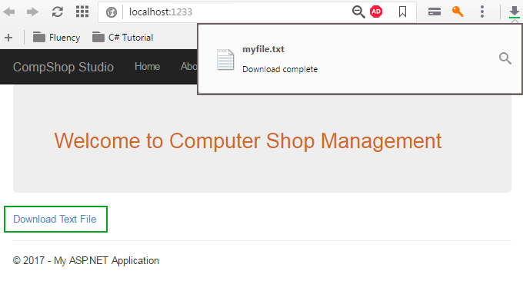
PartialViewResult
Returns HTML from Partial view.
Step 1: Add a partial page. Go to Solution Explorer Shared. Right-click on it and select Add View.
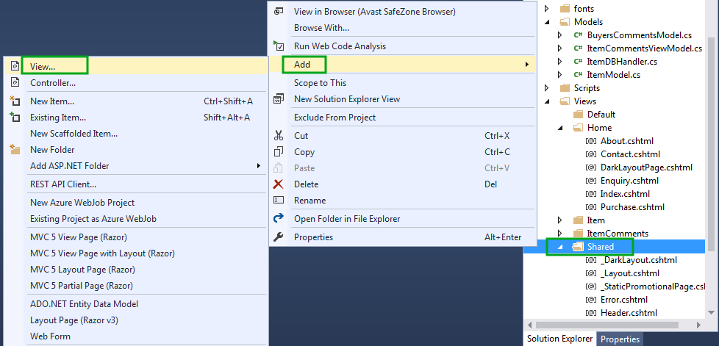Step 2: Create partial view page as described in this picture.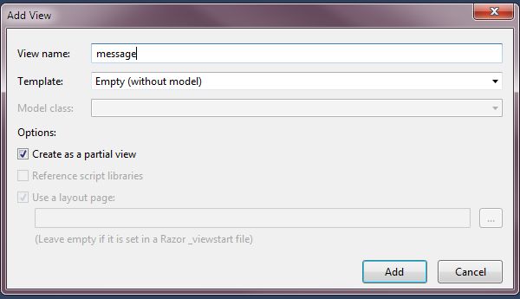Step 3: Add the following code in message.cshtml page.
This is PartialViewResult Example Output.
Step 4: Open HomeController.cs and add following line of code.
- [HttpGet]
- public PartialViewResult messagepage()
- {
- return PartialView("message");
- }
Step 5: Go to Index.cshtml and add this code.
- @{
- Html.RenderAction("messagepage", "Home");
- }

Output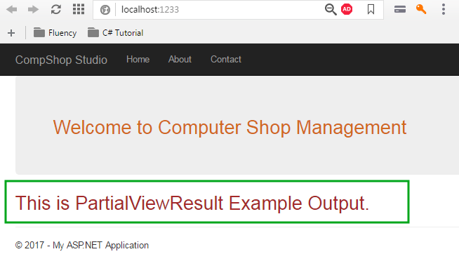

ActionVerbs are used when we want to control the selection of an action method based on a Http request method. For example, if we have two action method with same name then it can be respond based upon the HTTP request type(one action has to respond to Http Get and another method have respond to Http Post). ASP.NET MVC provides attributes to tweak how the actions can be selected based on the name.

Two different table
Branch table and student table

It
HR
CS

Different types of ActionVerbs
ASP.NET MVC supports different types of ActionVerbs.
- HttpVerbs.Get – retrieve the details from the server. Parameters will be appended in the query string.
- HttpVerbs.Post – submit new details.
- HttpVerbs.Put – Use to update an existing information.
- HttpVerbs.Delete – To delete an existing information.
- HttpVerbs.Head – Identical to GET except that server do not return message body
- HttpVerbs.Patch – Requests that a set of changes described in the request entity be applied to the resource identified by the Request
- HttpVerbs.Options – Represents a request for information about the communication options available on the request/response identified by the Request
In ASP .NET MVC, it can be achieve in two different ways.
Method 1: AcceptVerbs Attribute
We can apply multiple http verbs using AcceptVerbs attribute by using OR operator.
public class dotnethelpersController : Controller
{
[AcceptVerbs(HttpVerbs.Get | HttpVerbs.Post)]
public ActionResult EditEmpDetails(int id)
{
// retrieve the Details
}
Method 2: shortcut attributes
public class dotnethelpersController : Controller
{
[HttpGet]
public ActionResult EditEmpDetails(int id)
{
}
[HttpPost]
public ActionResult EditEmpDetails(string empCode)
{
}

Update

public ActionResult update(int prid)
{
using (var context = new AnujaEntities())
{
var data=context.products.Where(p => p.pr_id == prid).SingleOrDefault();
return View(data);
}

}
[HttpPost]
public ActionResult update(int prid,product p1)
{
using (var context = new AnujaEntities())
{
var data=context.products.FirstOrDefault(p => p.pr_id==prid);
if (data != null)
{
data.pr_name = p1.pr_name;
data.pr_price = p1.pr_price;
data.pr_date = p1.pr_date;
context.SaveChanges();
return RedirectToAction("Retrieve");
}
else
{
return View();
}

}
}

Retrive

[HttpGet]

public ActionResult retrive(product m)
{
using (var context = new AnujaEntities())
{
var p2 = context.products.ToList();
return View();

}

}

DELETE RECORD CODE

public ActionResult DeleteRecord(int eid)
{
using (var context = new ABCDEntities())
{
var data = context.Employee1.Where(p => p.empid == eid).SingleOrDefault();
return View(data);
}
}

[HttpPost]
public ActionResult DeleteRecord(int eid, Employee1 m)
{
using (var con = new ABCDEntities())

{
var d = con.Employee1.FirstOrDefault(p => p.empid == eid);
if(d!= null)
{
con.Employee1.Remove(d);
con.SaveChanges();

return RedirectToAction("Retrieve");
}
else
{
return View();
}

}
}

Data Annotation in MVC

It uses to implement model validation.

- Required
- Range
- Regular Expression
- Compare
- String Length
- Datatype

EMPLOYEE.CS

public class Employee
{
public Guid Empid

{ get;
set;
get;

}

[Required (ErrorMessage ="pls enter your name")]
[StringLength(10,MinimumLength =6)]
public string Fname
{
set;

}
[Range(18,50,ErrorMessage ="Age must be in between 18 to 50")]
public int age
{
get;
set;

}

[Range(typeof(DateTime),"01-01-2000","01-01-2020",
ErrorMessage ="DATE OF BIRTH MUST BE 01-01-2020")]
public DateTime DOB
{
get;
set;

}
public string Mobile
{
get;
set;

}

[Required (ErrorMessage ="MANDATE FIELD")]

[RegularExpression(@"\A[A - Z0 - 9_!#$%&'*+/=?`{|}~^.-]+@[A-Z0-9.-]+\Z)",ErrorMessage ="PLS ENTER CORRECT EMAIL")]
public string Emailid
{
get;
set;

}
public string username
{
get;
set;

}
public string password
{
get;
set;

}
public string ConfirmPassword
{
get;
set;

}

}
}

EmpController

public ActionResult create()
{
return View();
}

[HttpPost]
public ActionResult create(Employee emp)
{

try
{
if (ModelState.IsValid)
{
return RedirectToAction("Index");

}

return View();
} catch
{
return View();
}

}
}
}

Create.cshtml

@model dATA_ANNOTATION1.Models.Employee
@{
ViewBag.Title = "Employee Information";
Layout = "~/Views/Shared/_Layout.cshtml";
}

<h2>create Employee</h2>

@using(Html.BeginForm())
{
@Html.AntiForgeryToken()
<div class="form-horizontal">
<hr />
@Html.ValidationSummary(true, "", new { @class = "text-danger" })
<div class="form-group">
@Html.LabelFor(model => model.Fname, htmlAttributes: new { @class = "Control-label col-md-2" })
<div class="col-md-10">
@Html.EditorFor(model => model.Fname, new { htmlAttributes = new { @class = "form-control" } })
@Html.ValidationMessageFor(model => model.Fname, "", new { @class = "text-danger" })
</div>
</div>

<div class="form-group">
@Html.LabelFor(model => model.age, htmlAttributes: new { @class = "Control-label col-md-2" })
<div class=" col-md-10">
@Html.EditorFor(model => model.age, new { htmlAttributes = new { @class = "form-control" } })
@Html.ValidationMessageFor(model => model.age, "", new { @class = "text-danger" })
</div>
</div>
<div class="form-group">
<div class="col-md-offset-2 col-md-10">

<input type="submit"value="Create" class="btn btn-danger" />
</div>

</div>

